Pentecost 21A (Proper 24)

[RCL] Exodus 33:12-23; Psalm 99; 1 Thessalonians 1:1-10; Matthew 22:15-22

Come, Labor On

Paul’s letter to the church in Thessaloniki is believed to be the first of his surviving letters to be included in the Bible. This makes it the earliest existing example of Christian writing about Jesus and the emerging community of his followers. Evidence in the letter suggests that the Thessalonians have questions for Paul: There are believers who have become idlers, non-productive members of the community just waiting for Jesus to return—what should we do? What about those who have returned to worshipping idols? And some have died before Jesus’s return in the end of days—what will happen to them when he does?

Before addressing these issues, Paul butters the Thessalonians up. He compliments them for their “work of faith, labor of love, and steadfastness of hope in our Lord Jesus Christ”—which contradicts the earlier-named problem that some of their number have stopped working at all!

Note his emphasis here on “work” and “labor.” Paul knows what we all know: Faith, hope, and love do not come easy. Ongoing hard work is an important component of the life of any faith that is grounded in love for others—all others. We have to work at this. We work at this in all kinds of ways, including such mundane tasks as cleaning the house, washing the dishes, etc. Sister Joan Chittester addresses this connection in her book, Illuminated Life:

Work does not distract us from God. It brings the reign of God closer than it was before we came. Work doesn’t take us away from God. It continues the work of God through us … I must work as if the preservation of the world depends on what I am doing in this small, otherwise insignificant space I call my life.

Paul knows there is no time for idlers on the harvest plain, no time for worshipping idols, and no time to sit around and speculate on the future. Today, idols tend not to be made of wood or stone overlaid with silver and gold. The idols that lure us today are distractions of all kinds: money, greed, envy, consumerism, hatred of those not like ourselves, and inflexible ideologies. Even our obsessions with religion and politics can become idolatrous!

In this letter, Paul reminds the Thessalonians of the reputation they have as hard-working evangelists who have “turned to God from idols, to serve a living and true God.” They have a reputation to maintain as those who have followed Paul’s example, who have persisted in doing the work of God’s kingdom despite hardships along the way. ‘It’s time,’ he encourages them, ‘to continue the work you have begun.’ Again, the gentle art of leading people where you want them to go by showing them the best version of themselves.

We see a different tactic at play in this morning’s gospel lesson. There, we pick up the ongoing narrative of Jesus in Jerusalem, and witness his ongoing confrontations with various authorities. This time he is confronted by the Pharisees, concerned with keeping Torah faith despite the ongoing Roman occupation. And there are also gathered some Herodians, those who support the ruling family of Palestine, and therefore are seen by others to collaborate with the Roman Empire. It might seem odd that these two groups would be joining forces, but we know politics and religion often make for strange “bedfellows.” In this case, the Pharisees and Herodians both, for different reasons, have common cause to derail the Jesus Movement.

Together, they set about to test Jesus in public. They no doubt think they have a fool-proof plan to discredit him, bringing forth a question to trap him: about paying the tribute tax to Caesar. If he says Jews ought not pay the tax, some will agree with his sticking to Torah ideals, while others will question his sense of what is practical for survival in the Empire. (This was likely the position of the Pharisees.) On the other hand, were he to say “Yes” to paying the tax, such a practical answer will cost him both politically and religiously, possibly to the point of losing the support of his own followers. For in encouraging Jews to pay taxes to the Roman emperor, he would be siding with the descendants of Herod, who, at the beginning of Matthew, slaughtered all of Jesus’s young cousins!

It seems a foolproof trap they have laid for him. What could go wrong with their plan?

Plenty as it turns out! All Jesus has to say is, “Show me the coin used for the tax.”

Gleefully, his opponents produce a denarius—which shows an image of the emperor on one side, and an inscription on the reverse: “Tiberius Caesar, august son of Augustus, and High Priest.”

Now for the important context: This coin, for the Jewish people, is itself a forbidden idol. Such coins were not permitted to be used for offerings at the Temple—thus the reason for the money-changers and currency exchanges in the Temple courtyard.

That the Pharisees and Herodians would produce such a coin on the Temple Mount exposes them as hypocrites. Jesus calls them out as “actors” or “role players,” which is the root meaning of the word, hypokritai (hoop-ok-ree-tahee). Simply by producing the coin, they expose themselves as religious role players or posers, breaking the rules of the very system they seem to be protecting with their questions!

Jesus could stop there, but no. After getting them to say whose image appears on the coin, he replies, “Give therefore to the emperor the things that are the emperor’s, and to God the things that are God’s.” Like any respectable rabbi, Jesus turns their question back on them: Knowing what you should know, you decide about the tax. The real question is not about taxes. It’s about who you serve.

Now the familiar epigram in these lines is worth lingering over: “Give therefore to Caesar the things that are Caesar’s and to God the things that are God’s.” The parallel construction of the phrase might seem to suggest that the realms of Caesar and God are of equal significance. But the effect of the phrase is actually the reverse. Jesus does not suggest that the religious realm and the political realm deserve equal respect. Instead, the second clause all but nullifies the first. The realm of Caesar is vastly inferior to the significance of God’s realm, and in setting them in opposition like this, Jesus underscores that fact and ridicules the original question.

Jesus is saying in effect, ‘We bear God’s image. We belong to God as surely as your coin belongs to Caesar. Who do you actually serve?’ Remember what Jesus said in the Sermon on the Mount, “You cannot serve God and mammon!” That is: ‘You cannot serve God and money!’ (Matthew 6:24). Essentially Jesus takes the question posed to him about right practice in tax payment and turns it on its head: ‘Go ahead and toss Caesar a few denarii, but remember that life does not consist in wealth, possessions, and power, but rather in living according to the will of God.’

Jesus, like Paul after him, has one chief concern: Give to God what is God’s.

Their teaching echoes down to us with a strong imperative. This is no time for idle chat. No time for idlers. No time for returning to the worship of idols. There’s no time to worry about Caesar. Nor Herod. No time for posers and schemers. It’s time to continue the work of faith, the labor of love, and the steadfastness of hope in our Lord Jesus Christ.

As we sing,

Come, labor on!
Who dares stand idle, on the harvest plain
While all around him waves the golden grain?
And to each servant does the Master say,
“Go work today.” (Jane L. Borthwick, 1859, 1863)

Work we must, as if the preservation of the world depends on what we are all doing in this small, otherwise insignificant space we call our life.

Because it does matter. The world does depend on what on what we are doing in the small, otherwise insignificant space we call our life.

Our life is God’s life. And God’s Life is ours.

Amen.

Kirk Alan “Chief” Kubicek was introduced to a life of eschatological hope and expectation having been born and raised a Chicago Cubs Fan in the western suburbs of Chicago, IL. After having served in a variety of parishes from Corporate to Family size over the past 40+ years, I am currently Priest in Charge at Christ Church, Rock Spring Parish, Forest Hill, in the diocese of Maryland, a small but mighty congregation. I believe the preaching task is akin to gathering the fuel and setting a spark that hopefully will create a fire of inspiration in the heart of those hearing the Word. In my spare time, I play drums in a Grateful Dead tribute band, On The Bus, playing in the D.C Metro and Northern Virginia neighborhoods. I take great comfort in the words of Saint Julian of Norwich: “All shall be well, all shall be well, all manner of thing shall be well.”
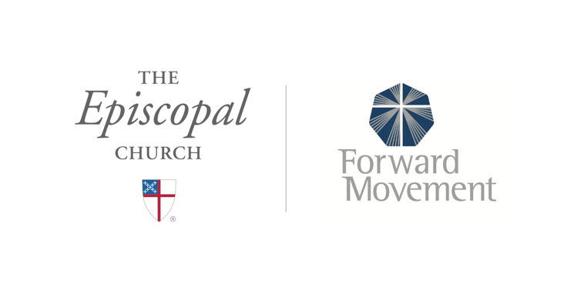
Sermons that Work and Bible Studies that Work are a joint offering of Forward Movement and The Office of Communication at The Episcopal Church.

https://www.episcopalchurch.org/bible-study/
https://www.episcopalchurch.org/sermons-that-work

