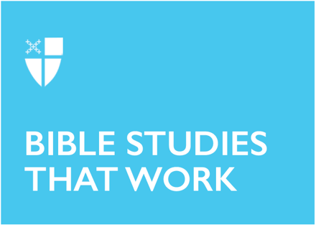

Pentecost 14A (Proper 17)
August 30, 2026
RCL: Exodus 3:1-15, Psalm 105:1-6, 23-26, 45c, Romans 12:9-21, Matthew 16:21-28
Opening Prayer |
Lord of all power and might, the author and giver of all good things: Graft in our hearts the love of your Name; increase in us true religion; nourish us with all goodness; and bring forth in us the fruit of good works; through Jesus Christ our Lord, who lives and reigns with you and the Holy Spirit, one God for ever and ever. Amen
Context |
The gospel of Matthew wants us to pay attention, to look closely, at what is happening. Literally! The author of Matthew uses several different verbs — phaino, theaomai, blepo, eido, horao — to reflect on various ways of seeing. But this gospel emphasizes horao in particular. In one sense, this word can mean a simple, “Behold.” But in another sense, it means to see with the mind or heart, to discern what and who are truly at stake in any situation.
Horao is the verb used in the Beatitudes, when we hear that the pure of heart “shall see God” (Matthew 5:8), as well as when Jesus explains that those who “saw” him when they fed the hungry, clothed the naked, and visited the imprisoned will be welcomed into the Kingdom (Matthew 25:37). In this gospel, horao also means experiencing what you see. This is part of the work of discipleship in the Gospel of Matthew: To see suffering is a call to viscerally experience it; to see something is to know intimately what it means. This verb captures exactly what Peter did so well in the verses right before the ones we study today: He saw Jesus and proclaimed him.
Jesus has just warned his disciples to “Watch out” (a form of horao again) for the teachings of the Pharisees, to pay attention instead to what Jesus says, and what Jesus does. Peter has evidently been deeply moved by this lesson, because he proclaims that Jesus is “the Christ, the Son of the living God” (v 16). Peter has paid attention—he has seen and discerned who Jesus truly is—and Jesus is so pleased that he renames him Cephas, the rock on which the vision of the church will be founded.
But for all the progress Peter makes in discerning Jesus’s identity, he utterly fails to discern what that identity means for the kingdom. Peter’s eyes recognized Jesus as the Messiah, but his imagination could not yet envision a Messiah who suffers. “God forbd it, Lord!” he exclaims, “This must never happen to you” (v 22). In this, Peter’s clear sight has failed.
And so Jesus rebukes him. Just lines after Peter received a new name and new identity as the “rock,” now Jesus calls him a new name, “Get behind me, Satan!” Peter is no foundation stone, here, but a stumbling block, an adversary, right in the middle of Jesus’s path. Jesus argues back that Peter has “set his mind not on divine things,” that instead he’s using his phroneó—his way of thinking and orienting himself —from a merely human vantage. At the idea of a risk to Jesus’s life, Peter lost his newly claimed vision of the kingdom of God, and set his thoughts on death. It is no mistake that right after our verses from today, Jesus will take Peter, James, and John to the mountain top to reorient their vision, transfiguring their vision through the bright revelation of his truest self.
Theological Reflection |
There’s something so reassuring about Peter blurting to God all his fears. Because—like Peter—I, too, find myself fearful about my future; I often try to correct God according to my own vision and plan. I imagine Peter’s eyes—blinded by tears, hearing his best friend detail his future suffering and death—and I see how his own grief and fear have obscured his great insight: that Jesus is the King who came to liberate us from the death-dealing empires of the world. He is the Christ, the Son of the Living God, whose touch is healing, and who conquers all death. Obviously he cannot die! So here’s Peter—pulling Jesus gently aside, and chiding him, “No, no, no, far be it from you, Lord! This isn’t the plan for Christ at all! Don’t you know you’re supposed to usher in a great Kingdom? Kings do not suffer and die.”
Peter’s attempts at reorienting Jesus’s vision backfire. Jesus reminds the disciples that his kingdom can only be experienced through the way of the cross: “Take up your cross,” he says, “and follow me.” The cross is a burden that casts our gaze not to the starry firmament, but to the ground before us, to trace footprints of the Messiah who goes ahead. A heavy commitment, Peter must think, but also one that reveals God’s kingdom come to earth.
We all know this commitment to bear our cross painfully well. While Jesus is not telling us to stay in abusive or toxic situations, he is explaining that true discipleship is uncomfortable in ways large and small. It hurts, sometimes, to let genuine love lead our way; to cling to what is good when the world seems so bad; to bless those who persecute us and to swallow our own pride. It also hurts to give up lucrative careers, comfortable friendships, or social respect to follow where Christ leads. That kind of faith is unfashionable right now. Seeing the poor, the hungry, and the vulnerable uplifted, liberated, and healed has never been popular with those who build their kingdoms on wealth, violence, and status. So it is uncomfortable—and even dangerous—to give up our visions of success, power, and social prestige to follow Jesus, and see his vision for the kingdom instead of making our own. Make no mistake—there is grief that comes with this displaced vision: a painful death and a no-less painful resurrection.
Jesus’s answer to Peter is critique and comfort both: By offering your life, you will gain a far greater one. Being a disciple demands loss; you cannot be constantly comfortable and still be allied to those the world has named “last.” Being a disciple demands vulnerability; you must deny yourself and become a servant for Christ.
But discipleship will also give you a glimpse, an experience—horao—of the kingdom. Jesus will see every act of painful discipleship, and who you have served ahead of yourself. Being a disciple may call for death; the life you planned will almost certainly be lost. Yet in following the footsteps of Christ—against the powers of the world, alongside those who are subject to its wrath—Jesus promises that you will find a new life with him. It is there, with Jesus, bearing our own crosses on our backs, that our sight is transformed to see creation as God does: full of beauty, courage, grace, and joy—a place precious enough for Easter morning.
To follow Jesus will cause discomfort. Maybe, for you, it already has. And yet you will behold—horao—a kingdom that can be seen no other way.

Reflection Questions |
- Where have you recently seen a glimpse of God’s kingdom?
- When have you experienced the discomfort of discipleship? How are you being called to embrace it today?

- Peter’s fear over Jesus’ suffering and death blinded him, distorting his vision of God and God’s kingdom. What are some things that keep you from seeing God, yourself, or the world clearly?"
- Jesus tells his disciples that he will “be killed, and on the third day be raised.” Peter does not seem to hear the Easter promise of Jesus’s teaching; he’s stuck on the Good Friday portion. Where are you experiencing so much of the discomfort of discipleship, that you are struggling to see Easter morning?
Faith in Practice |
This week, take time to walk through someplace familiar to you—your grocery store, your school, or neighborhood—with this prayer: “Lord Jesus, help me see your kingdom.” Pay attention. Try not to analyze; just notice: Where do you see beauty? Where do you see suffering? Where do you see unexpected acts of love or mercy? Who might Jesus be inviting you to notice more carefully? At the end of your walk, write down one thing you saw and offer a prayer of thanksgiving or intercession.

Ms. Chesirae Valentine-Karlin is a seminarian at the General Theological Seminary, the Director of Children and Youth at All Angels’ Church on the Upper West Side, and a postulant to the priesthood from the Diocese of Arizona. When not writing papers or teaching acolytes, she’s probably playing in Central Park with her husband James, son Beckett, and cat Ruah.

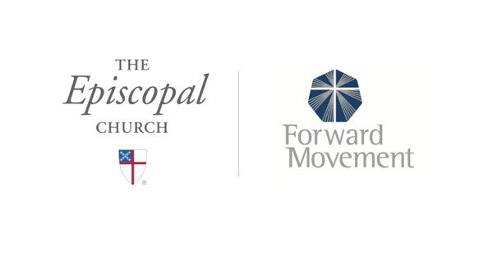
Sermons that Work and Bible Studies that Work are a joint offering of Forward Movement and The Office of Communication at The Episcopal Church.

https://www.episcopalchurch.org/bible-study/
https://www.episcopalchurch.org/sermons-that-work

