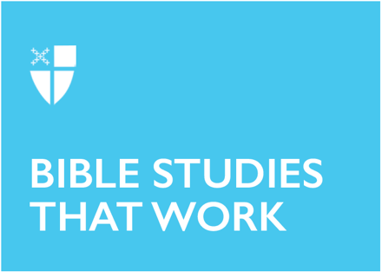

Pentecost 13A (Proper 16)
August 16, 2026

RCL: Exodus 1:8 – 2:10; Psalm 124, 18-19; Romans 12:1-8; Matthew 16:13-20

Prayer |
Grant, O merciful God, that your Church, being gathered together in unity by your Holy Spirit, may show forth your power among all peoples, to the glory of your Name; through Jesus Christ our Lord, who lives and reigns with you and the Holy Spirit, one God, for ever and ever. Amen.

Context |
Many scholars accept the hypothesis that Matthew uses Mark’s gospel as a primary source for these verses, but makes slight edits to it. This hypothesis rests on how closely Matthew 16 mirrors the content of Mark 8:11-21 (Matthew 16:1-2) and Mark 8:27-9:1 (Matthew 16:13-28). In his telling, Matthew only makes minor editorial changes from the earlier text of Mark. The largest departure comes in details added to Peter’s confession. In Matthew’s version, Peter is blessed for his confession, whereas in Mark, Peter’s confession is shorter and corrected by Jesus.

The conversation between Jesus and his disciples takes place in the district of Caesarea Philippi, a city built by Herod the Great’s son Philip in honor of Tiberius Caesar. Philip added his own name to the rebuilt city to differentiate it from the Caesarea, a coastal city in Judea. The district of Caesarea Philippi is located north of Palestine and had a predominantly Gentile settlement. Before Philip rebuilt it, the city was known as Panion or Paneas because of a shrine in the region built to honor the Greco-Roman God of Pan.

Bringing geography into focus matters here, as the revelation Peter speaks in Caesarea Philippi, a Gentile territory, underscores the universal nature of the gospel’s message. Looking back to earlier verses in this same chapter, when Jesus is tested by Pharisees and Sadducees, we see that they were in a predominantly Jewish territory. The Pharisees and Sadducees, rival religious groups, are firmly situated within the Jewish context and the religious codes both groups tried to interpret for believers. This code shaped their vision of God and the scope of God’s love. However Peter proclaims the truth of Jesus’s identity from a gentile city. The geography widens Peter’s confession, revealing God’s claim over all territories. This geography hearkens back to Jesus’s point in the previous verses: broadening the reach of God’s salvation beyond religious codes and affiliations, to encompass those beyond the borders of Jewish observance.

With Sunday morning being the most “segregated hour” in the United States, what boundaries limit that proclamation of Christ today? Is there a part of us that wants to only have certain people hear it or do we only want certain people around us when it is proclaimed? What geographic and psychological markers limit us from living into God’s vision for all?

Theological Reflection |

Rabbi Lawrence Kushner uses a two-circle metaphor to explain how we approach our relationship with the divine. Imagine two circles: one big circle, representing God, and a smaller one, representing us. In the first metaphor, the big circle, God, is above the smaller circle. In such an image, there is a natural hierarchy. The relationship is vertical, a view supporting by the western idea that God is “up there” and we are “down here.” We talk to God, and God tells us what to do.

In the second metaphor, the same two circles are present. However, now the smaller circle is inside the big circle. Rabbi Kushner goes on to say “And the goal here is not to pray to God or have God tell you what to do, but to realize that you have been all along, contrary to all your illusions, a dimension of the divine, and in moments of heightened spiritual awareness, the boundary line which is the little circle defining you inside the big circle, momentarily is erased. Momentarily is blurred, and it is no longer clear where you end and God begins.”

Amidst a cacophony of voices clamoring to assign Jesus prophetic status, Peter speaks up, revealing something of God. In the moment of his confession, the boundaries of the small circle—the encompassing of his mortal flesh and blood—are momentarily erased, and God enters. Earlier in the text, Jesus had expressed frustration at “flesh and blood” religious leaders. They claimed to be God’s people but could not read the signs of the times. Yet here Peter, who is surely of “flesh and blood” experiences a rare moment of clarity—even divine joining—revealing, “You are the Christ, the son of the living God.”

“Flesh and blood” is an idiomatic expression that means to encompass the entirety of the human being, including their weaknesses and limitations (see 1 Cor 15:50, Gal 1:16). It stands in contrast to the heavenly Father, who is whole and holy. Despite Peter’s “flesh and blood” status, despite his weakness and imperfection as a disciple, there is this moment of grace that breaks through the barriers of his human self to reveal something holy and lifesaving in his confession. Peter’s revelation and testimony would become the credal cornerstone of faith for many. Thus, Jesus pronounces of Peter, “on this rock I will build my church.”

As we saw earlier, in the beginning of Chapter 16, Jesus is surrounded by religious authorities, who could not read the signs that Jesus was discovering in the Law. This scene offers a stark contrast with God’s moment of entry in Peter’s revelation (Verse 15), which occurs in a geographic region that is home to the gentiles, not the religious influencers. This revelation takes place in the margins than the center of power, not in religious geography, but in Gentile territory and among ordinary people. In this we see that God’s revelation is for all people and not just a select few.

This passage has been significant in world church relations, as Peter’s moment of grace has been used across the centuries to argue for supremacy of Peter, and therefore to establish the Catholic claims about the legitimacy of the role of Pope. And yet we would do well to ask what Jesus means when he declares Peter a “rock” on which he will build his church. In that moment, Jesus is responding to Peter’s testimony: “Blessed are you, Simon Bar-Jona! For flesh and blood has not revealed this to you, but my Father who is in heaven” says Jesus. In Peter’s testimony, Jesus recognizes his Father in heaven revealing something to Peter. The rock that the church is built on is not in the person of Peter, but the clarity and strength of his testimony, which is only possible through the grace of God, rather than some superior merit or intelligence in Peter.

To Jesus’s question—“Who do you say that I am?”—we might be quick to quote texts, our favorite influencers, theologians, or credal statements. But the question begs us to go deeper. An intellectual answer is a half-baked response. What about an answer in which love has broken through, as it did in Peter? God does not relate to us in a vertical, hierarchical relationship, but rather one in which our boundaries blur.

Reflection Questions |

- Reflect on the idea of Sunday morning being the most “segregated hour” in the United States. Is that true in your own context? What boundaries limit that proclamation of Christ to all people in your own neighborhood?
- What boundaries in your own heart limit the reach of God’s love? Are there groups or places or causes to which you cannot see it go? What does this reveal?
- What moments in your life can you recall where God broke through “flesh and blood” to dwell with you?
- Jesus asks, “Who do you say that I am?” What is your answer?
Faith in Practice |

This week, take up the metaphor of the two circles from Rabbi Kushner as a guide to your prayer. Do you pray more in the vertical hierarchical model—in which God is “up there” and you are “down here”? What would it look like to place your smaller circle inside the circle of God? What difference would such an image of prayer make to your practice? You might experiment with exploring Centering Prayer, which invites presence as the primary form of prayer. Learn more about the practice of Centering Prayer developed by Thomas Keating.

The Reverend Deepu Varughese George is a priest in the Diocese of West Texas, currently serving as Priest-in-Charge at Grace Episcopal Church, Weslaco, TX. He completed his theological education at Nashotah House Theological Seminary in Masters in Pastoral Ministry in a Hybrid-Distance Program. He holds a Ph.D. in Human Development and Family Science and is currently an Associate Professor in Family Medicine at the University of Texas Rio Grande Valley School of Medicine. His work focuses on integrating behavioral health into primary care to increase access to mental health in the Rio Grande Valley, a region located along the U.S.-Mexico border.

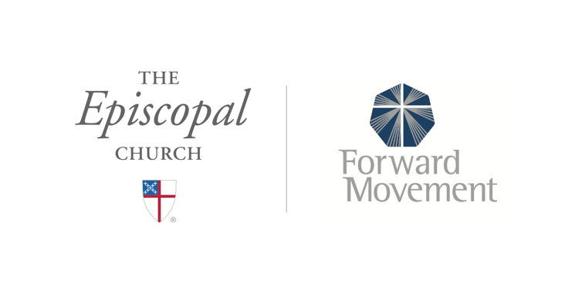
Sermons that Work and Bible Studies that Work are a joint offering of Forward Movement and The Office of Communication at The Episcopal Church.

https://www.episcopalchurch.org/bible-study/
https://www.episcopalchurch.org/sermons-that-work

Eng, D. K. (2022, January 12). The ethnic-specific church and MLK’s “most segregated hour” line. SOLA Network. https://sola.network/article/ethnic-specific-church-mlk/
Tippett, K. (Host). (2019, March 21). Lawrence Kushner — Kabbalah and everyday mysticism [Audio podcast episode]. In On Being. The On Being Project. onbeing.org

