Pentecost 14 (A) – Proper 17
[RCL]: Exodus 3:1-15; Psalm 105:1-6, 23-26, 45c; Romans 12:9-21; Matthew 16:21-28

Say Yes

Peter says it can’t happen: Jesus can’t be allowed to die.
Mind you, this challenge to Jesus follows right after the passage we heard together last week, in which Peter totally gets the question right when Jesus asks him, “Who do you say that I am?” Peter proclaims that Jesus is “the Messiah, the Son of the living God.”
Jesus says, that’s right. That’s who I am. I am the Son of God—and I will die.
And Peter says it can’t happen.
In the Neil Gaiman novel Good Omens, the end of the world is ushered in by the birth of the anti-Christ, as foretold by Agnes Nutter, a 16th century witch. It’s a great book, like most of Neil Gaiman’s work, well researched, poignant, hilarious, and now available as a series on Amazon Prime.
In the story, four people come from the four corners of the world to find each other. They are the four horsemen of the apocalypse: There’s War, a fiery haired woman who flies in from a war zone somewhere in the world. Then there’s Famine, a man who, at the time of the apocalypse, is making his money selling food that isn’t really food. Then there’s Pollution, a dark-haired woman who has stepped in for the apocalypse after the retirement of Pestilence.
We have to forgive Neil Gaiman for thinking that pestilence, or disease, wasn’t a threat anymore. He wrote Good Omens in 1990, thirty years before the COVID-19 pandemic.
Three of the four horsemen of the apocalypse ride into the town in which the witch predicted Armageddon would take place. Pollution, Famine, and War all ride motorcycles and arrive looking for the fourth horseman: Death.
Arriving in all black, Death opens his helmet to reveal that his face is just bones.
One of the others sneers, “Where have you been?”
Death answers, “I never left.”
Of all the Bible’s greatest enemies, Death is the most real to us, the most relevant to our lives. It indeed has never left. It has been with all of us from the very beginning and long, long before any of us was born.
In the Bible, Death is the last enemy to be destroyed. Death is the opposite of life. And death is everywhere, striking all the time.
Death strikes this week, as wars rage and terror strikes around the world.
Death strikes this week, in every tragedy that made the news.
Death struck this week, in every state in the nation, and all around the world, when families received the unexpected news that a loved one had died, in untold tragedies that didn’t make the news.
Death never left.
We don’t like to think about Death. We push it away. Which why some part of us understands exactly why Peter says what he says in this Gospel lesson. His beloved friend and teacher, Jesus—the one he left everything to follow—tells them that he will suffer and die.
As Matthew tells it, Peter took Jesus aside and began to rebuke him, saying, “God forbid it, Lord! This must never happen to you.”
We may find ourselves thinking, and rightly so: “Who would dare to rebuke the Son of God? Bad move.”
But it turns out that the more you live, and the more death you see, the more you get exactly why Peter says what he says here. I think most of us, maybe all of us, if we were in Peter’s shoes, would’ve said the exact same thing.
“I left everything for you! I love you! You’ve brought meaning to my life that I never knew before. What on God’s green earth would I DO if you died?”
It’s easy to forget, when we read these stories, that Peter didn’t know the ending. All he knew was what he knew. And he knew that death was—is—a permanent condition. If Jesus died, as Peter saw it, then that was it. Sure, Jesus talked about resurrection, but hearing about something miraculous is very different than seeing it for yourself.
So Peter takes him aside and says this just can’t happen.
Jesus answers with his famous call for the disciples to take up their cross and follow him. Again, we risk missing the meaning here. The cross has come to have a special meaning in our lives, in Christian culture, and in the culture at large. The cross doesn’t mean to us now what it did then, before Jesus ever hung on one.
Back then, the cross was an instrument of torture, fear, and death. To take up a cross was to meet Death, face to face.
But we do know the end of this story. We know what Peter doesn’t know: That death will come for Jesus, that that won’t be the end.
Death never left, but Death doesn’t get the final word.
The worst thing that can happen is never the last thing. Faith may die on Friday, but it rises again every Sunday—and that is why we are here in church.
Peter says it can’t happen. Jesus says, Get Behind Me, Satan, because Jesus knows what comes after death comes.
“I am here,” Jesus says, “and Death no longer has the final word.”
None of us can say “No” to death.
Jesus reminds us that though we cannot say “No” to Death, we can say “Yes” to resurrection, “Yes” to Life—because with all of the world’s horror comes all its beauty, too.
William Stafford wrote a poem called Yes. It goes like this.
It could happen any time, tornado,
earthquake, Armageddon. It could happen.
Or sunshine, love, salvation.
It could, you know. That’s why we wake
and look out––no guarantees
in this life.
But some bonuses, like morning,
like right now, like noon,
like evening.
Death will come.
But so will sunshine, love, salvation.
And Jesus will come here with us—in bread and wine and water and words and us.
Jesus, over whom Death did not win, here with us forever: in morning, in right now, in noon, in evening. And in the darkest night of your life.
Jesus reminds us that it will happen. But Death does not have the last word.
You can say yes, unafraid. Amen.

Anna Tew is a Lutheran (ELCA) pastor serving Our Savior’s Lutheran Church in South Hadley, Massachusetts, where she has served for a full decade. Originally from Alabama, she went to seminary at the Candler School of Theology at Emory University in Atlanta. Anna enjoys being outdoors: hiking, running, snowboarding, and many other pursuits. She is also a Level 2 CrossFit coach and enjoys training herself and helping people with all types of bodies to be strong, resilient, and ready for a challenge.
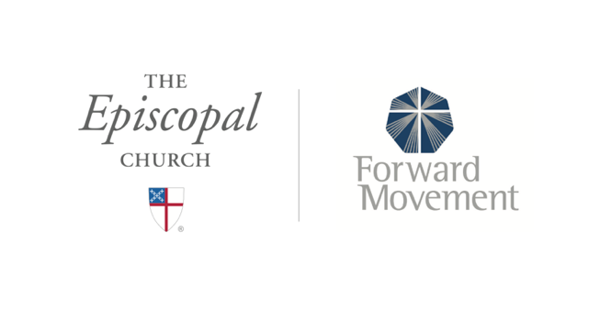
Sermons that Work and Bible Studies that Work are a joint offering of Forward Movement and The Office of Communication at The Episcopal Church.

https://www.episcopalchurch.org/bible-study/
https://www.episcopalchurch.org/sermons-that-work

