Pentecost 13 (A) – Proper 16
[RCL]: Exodus 1:8-2:10; Psalm 124; Romans 12:1-8; Matthew 16:13-20

Every Part of the Story

Every part of the story is important.
Every piece of the puzzle, every theme in the narrative, every member of the body.
There are so many pieces to our story.
Take today’s Exodus reading: Slavery. A jealous Pharaoh. Infanticide. A pair of possibly lying midwives. A hidden baby. A brave mother. A tar-coated basket. A princess. A well-timed sister. This origin story rivals any Marvel epic!
All of these details—all these themes and characters and plot-lines—add up to this central claim: God saves.
Consider the midwives. They ought to be terrified—they work for the Pharaoh who is fearful in a cowardly way—and yet they are not afraid. They choose to fear God instead of man, and so they use their power in a courageous act of civil disobedience.
“Fear of God”—as it’s used throughout the Old Testament—is more a concept about human decency, than human fear. The “fear of God” in a human being acts as a stimulus for good and a restraint of evil. Thus the midwives—when faced with a conflict between the laws of God and those of the Pharaoh—follow this goodness, this inner conscience, the “fear of God” within them.
What would have happened if they had succumbed to the fear of man? What would have happened to so many babies in the nation of Israel? To the specific baby at the center of this story? To the baby who grows up and, after twists and turns of his own complicated story and identity, went on to free the oppressed, leading his people out of slavery in Egypt. What would have happened to the history of not just Israel, but all humanity, had this baby not gone on to oversee the demise of Pharaoh and his armies in the very waters Pharoah once used to threaten these innocent children? The midwives change the course of human history.
Then there is the mother who hides her child, the sister who watches from a distance, the daughter of Pharaoh who refuses to see an enemy and instead sees a baby, and the unnamed hands that build a basket and set it among the reeds. Even the basket is an important character here, with its own story—hearkening back to the ark that Noah built; here is another flotation device carrying people away from destruction and death, into freedom.
Each action is small. Each action is essential. It is God who brings salvation through these ordinary objects, ordinary people, ordinary decisions.
Of course, none of these individuals could see the whole story. In the moment, there is fear, ambiguity, and cost. On the page, the story can seem overly simple, as we know the outcome as we read. But do not be deceived: It is never uncomplicated to be human in a broken world.
This is one gift the midwives offer us. They remind us that we are not called to carry the whole story. We cannot bring about salvation. We are called only to do our part within it. It is not perfection God seeks from us, but faithfulness, relationship, and discernment. We are not responsible for control of the outcome, but for courage in the moment.
Paul writes something similar in the letter to the Romans, a few thousand years later. He explains that the body does not consist of one member, but many. Each member has gifts. Each has a place. Each is needed, but none is sufficient alone. Someone has to be the little toe—and have you ever tried to walk or run without your pinky toe?
We are not all the same part, and so we are not all called to the same task. Some are hands, some are feet, some are eyes, some are hidden and unnamed. But all belong. It is not our job to carry out the role of the entire body, only Christ can do that—and he did so with his own body.
Our calling is simpler and harder, a path of surrender: to be faithful where we are planted. To become what we have been given to be. We do not need the full picture, every detail, to know that Christ is with us and within us. And know this: We do not often get the tidy resolution or full clarity we often expect from other stories.
In the Gospel, people are still trying to sort out the story—in this case, the identity of the protagonist. Who is Jesus?
Some say Jesus is John the Baptist bringing fire and revolution. Some say Elijah, combative and declarative. Some say Jeremiah or one of the prophets—a voice of truth preparing the way. All those figures mattered, each voice had their place. But Jesus is not a secondary character. He is the protagonist, bringing main character energy that rivals none.
So he asks Peter, “But who do you say that I am?”
The scene is important. Jesus is in Caesarea Philippi, and the location is a literary device that frames the question. The area was full of temples and shrines to ancient religions, markers of Ba’al, Pan, and Caesar. The scholar Barclay writes, “It is as if Jesus deliberately set himself against the background of the world’s religions in all their history and splendour, and demanded to be compared to them and to have the verdict given in his favour.”
In such a place, Peter answers the question simply, plainly: “You are the Messiah, the Son of the living God.”
While it is a simple answer, the meaning is deeply confusing. What does it mean that Jesus is the Messiah? Does this mean there will be no more war, no more violence, no more oppression? Does this mean all our hardships will end in neat resolutions?
No. Because Peter, like all of us, is called to play only a part in the larger story. The large story of salvation arrives with a lot of tragedies. Even our Savior dies a criminal’s death on the cross.
“But who do you say that I am?”
We cannot decide who Christ is solely based on the stories others tell us, or even only based on the traditions we inherit. At some point, the question must become personal: Who is Jesus to you?
The answer is never static—nor should it be. Like any good relationship, our relationship with Jesus deepens over time. It unfolds. It matures. Like anything rooted in living soil, it grows season by season.
We live in a world as complex as the one captured in the book of Exodus—a world marked by fear and oppression and violence, but also by courage, compassion, and unexpected grace. Even today, courageous midwives choose the fear of God over the fear of man.
It can be tempting for us to try to shoulder it all, to try to be the savior. And it can also be a temptation to just run away, to pretend none of it is happening.
But Paul reminds us, and Exodus shows us, and the Gospel insists: salvation belongs to God. Christ alone saves. Christ alone leads us out of bondage. Christ alone carries the weight of redemption.
Every part of the story matters; every piece of the body matters, because Christ is at work through all of us. We may never part the sea. We may never stand before Pharaoh. We may never be named the rock of the Church.
But we might be a parent who makes impossible sacrifices for their children. We might take professional risks in choosing to follow God instead of man. We might keep watch over a basket in a river and discover a calling we never anticipated. We might take the role of a very, very important pinky toe.
And that is enough. As complicated and long and difficult as our story is, God is with us. God alone can save us—we do not have to. Our help is in the Name of the Lord, the maker of heaven and earth.

The Rev. Anna Sutterisch is passionate about new ways of being and doing church, and is excited about sharing the Gospel in a way that is relevant and life-changing to today’s people in today’s world. Rev. Anna holds degrees in English and Viola Performance from Baldwin Wallace University and Conservatory, and is a proud graduate of Bexley Seabury Seminary, where she serves on the Board of Directors. She is honored and humbled to serve as the priest at St. Martin's Episcopal Church in Chagrin Falls, a small, strong congregation that loves liturgy, God, and our neighbors, and tries to bring Christ's light and life into a broken and hurting world. She lives in Cleveland with her spouse (also a parish priest), their two small boys, and two cats, and loves to run, cook, and eat vegetables.
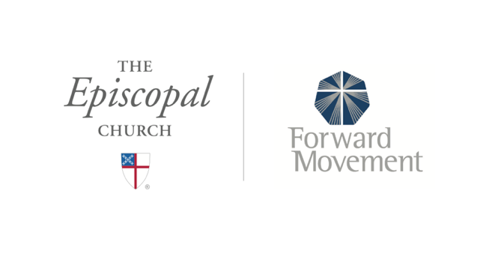
Sermons that Work and Bible Studies that Work are a joint offering of Forward Movement and The Office of Communication at The Episcopal Church.

https://www.episcopalchurch.org/bible-study/
https://www.episcopalchurch.org/sermons-that-work

