Pentecost 12 (A) – Proper 15
[RCL]: Genesis 45:1-15; Psalm 133; Romans 11:1-2a, 29-32; Matthew 15: (10-20), 21-28

Seventy Times Seven

The story of Joseph is such a beautiful one. Perhaps you know the story from the musical, “Joseph and the Amazing Technicolor Dreamcoat.” There’s something about putting bible stories to music that helps them stick in our heads and our hearts a different way. And, if you’ve never seen the movie, you now have a plan for tonight!
Here’s a little recap of the story of Joseph and his brothers. Joseph, his father’s favorite, had these dreams that proved prophetic. Now the sibling jealousy got so bad that the brothers decided first to kill Joseph, and then, in a moment that might be interpreted as God’s providence, to sell him into slavery instead. But Jospeh just becomes the poster boy for making it from rags to riches. After being thrown in jail, Joseph continues to dream, and his dreams get him an audience with Pharoah. Lo and behold, he becomes Pharoah’s right man.
Now, he is in a position of power, and his brothers are in need. The desperate brothers come to Egypt, in hopes that they might find some food to save their lives. And Joseph meets them, but the brothers don’t recognize him. After testing the brothers, and seeing that they have changed, Joseph decides to reveal himself. Now, let’ s admit this is a complicated family! Remember their sibling rivalry the next time your kids or grandkids can’t seem to get along!
In today’s portion of the story, we see Joseph reveal himself to his brothers. First, he gives them all a little space from prying eyes by sending everyone away. And then he weeps, telling them who he is. And then he says one of the most stunning sentences: “Come closer to me.” So simple, but so beautiful. Can you imagine? These brothers have betrayed Joseph in the deepest way. They have hurt him profoundly. And yet here Joseph is, beckoning them closer. It’s the opposite of what many of us want to do when we have been hurt.
The sentence is small in the story, but the lesson reaches deep into the heart. We live in an age where there are deep divisions—where we feel wronged by others, rightly or wrongly. We live in a time when so many have chosen to cut off those who think or feel or behave differently from them—even when that difference is in their own family. Here, we are given a completely different witness. One that draws closer instead of pulling away. One that invites in after hurt and betrayal. One that steps into relationship, instead of stepping away from it. One that keeps open the possibility of change.
We see something similar in today’s gospel lesson – Jesus and the Canaanite woman draw near to each other, even through a profound disagreement. They hold very different worldviews, and yet neither one of them walks away. They listen, interact, and ultimately come together and share in the healing that needs to happen. It happens not despite their difference, but through it.
All of us have others about whom we hold judgements. And all of us have been deeply wounded by someone near and dear to our hearts. What might it be like to beckon them closer, to allow a relationship to take root and develop in the soil of past disappointments. I wonder how we might be changed by drawing nearer to one another instead of distancing ourselves. To find healing we have to get close: close to our hurt, close to our hopes, close to our longing for healing, and when it is right, close again to the person with whom relationship has been lost.
Joseph could have sent his brothers away. In fact, they never would have realized who it was they had spoken to had he sent them away. Joesph would’ve been able to keep being “right,” to have come out on top, and his brothers almost certainly would have died, returning to the land reeling from famine when they had exhausted their resources.
Instead, with all his power—with all his favor from Pharoah and his capacity to control the food of the region—Joesph beckons to the siblings he once loved and grew up with, the ones who hurt him and even tried to kill him—and asks them to come closer to him. He crosses over the divide, showing them a bridge back to one another. He shows us what it is like to forgive.
Perhaps this morning you find yourself divided from someone—maybe a friend or family member or maybe even someone in this church. Maybe it’s a long-standing divide, fueled by wrongs that happened decades ago. Or maybe it’s more recent, a crack between you that gets solidified every day. Maybe it’s over something that feels huge—a betrayal of massive proportion, a real wrongdoing—or maybe it’s over something smaller—a personality trait that grates you the wrong way, one irritation too many. Maybe you find yourselves in opposite places on the political spectrum, each completely baffled by the conclusions of the other.
Whatever your specific situation, bring that person and the issue that you have with them to your mind for a moment. Picture their face, their smile. Now, imagine saying, “Come closer to me.”
It’s hard work, certainly. But it’s also certainly holy work. Joseph shows us the profound healing that came to his whole family because of his willingness to be vulnerable, his willingness to draw closer, not separate.
I don’t know your situation of division—only you do. And God doesn’t call us to stay or go back into places of abuse or mistreatment.
But if that is not your story, then consider the story of Joseph. Is it perhaps time for you, too, to draw closer? Forgiveness and healing come hand in hand. In a world that so needs to be healed, perhaps we can offer forgiveness. As Joseph did. And as Jesus commanded us to do, not once, not seven times, but seventy times seven times. Amen.

The Rev’d Jazzy Bostock is a kanaka mail woman and serves two communities in Wai'anae on the west side of Oahu, St. John the Baptist Episcopal Church and Maluhia Lutheran Church. She and her wife have two boys, Theo, 5, and Sam, 1, a garden, some chickens, bees, a cat and a dog. She loves to garden, cook, laugh, and be barefoot.
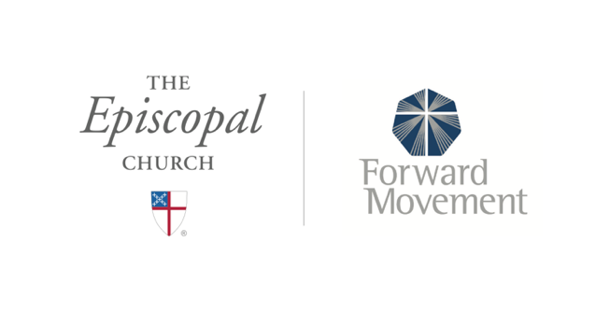
Sermons that Work and Bible Studies that Work are a joint offering of Forward Movement and The Office of Communication at The Episcopal Church.

https://www.episcopalchurch.org/bible-study/
https://www.episcopalchurch.org/sermons-that-work

