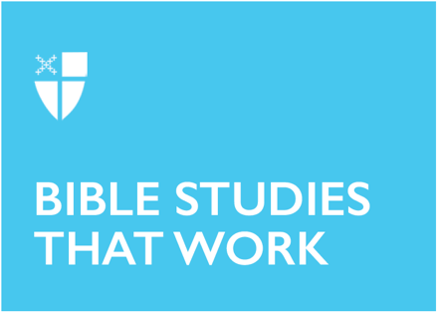

Pentecost 11 (Proper 14 A)
August 9, 2026

RCL: Genesis 37:1-4, 12-28; Psalm 105:1-6, 16-22, 45b; Romans 10:5-15; Matthew 14:22-33

Opening Prayer |

Grant to us, Lord, we pray, the spirit to think and do always those things that are right, that we, who cannot exist without you, may by you be enabled to live according to your will; through Jesus Christ our Lord, who lives and reigns with you and the Holy Spirit, one God, for ever and ever. Amen. (Book of Common Prayer, 232)

Context |

One of the major themes of the Gospel of Matthew is the connection between Jesus and the scriptural tradition of ancient Israel. Of all the gospels, Matthew contains the most references to Hebrew scripture, often focusing on the ways Jesus fulfills the promises of that Scripture. Today’s readers must be careful to acknowledge Matthew’s interpretation of this scriptural fulfillment without erasing other meanings attributed by the ancient Israelites or the tradition of rabbinic Judaism that developed in parallel with Christianity across the centuries.
Matthew invites us to imagine the essential nature and character of God, who moved over the waters of creation (Gen 1:1), who called a people into covenantal relationship (Gen 17:1-8; Deut 7:9), who liberated that people from slavery (Ex 3:17; 15:13), and who time and again sent prophets to communicate to the people how they ought to live (Isa 58:6-14; Amos 5:14-15; Mic 6:8). According to Matthew, God has been telling the story of relationship, liberation, and abundant life for all from the very beginning, and that story continues through the life and ministry of Jesus.
Throughout Matthew’s gospel, Jesus teaches us how to understand God, how to see the threads of God’s compassion, steadfast love, liberation, and justice. These themes are woven through the fabric of scripture and revealed in the reign of God. The shalom of abundant life can be known when we follow Jesus’s example and practice compassion, love, liberation, and justice within our communities.

Theological Reflection |

Matthew’s account of the miracle of Jesus walking on the water follows directly after two other notable events: Jesus learning about the death of John the Baptist and his feeding the crowd of five thousand men, plus women and children. When Jesus first hears the news of John’s death, he tries to retreat from the crowds to pray, but he is surrounded by people. When Jesus witnesses the needs of the crowd, he has compassion for them (Matt 14:14) and meets their needs for healing and nourishment. As soon as he finishes that work (v 22), he packs his disciples onto a boat and retreats up the mountain to pray in solitude—a textual allusion to Moses climbing Mt. Sinai to pray (Ex 32:30-4). In this intentional pursuit of rest, Jesus invites us to prioritize holy rest. The work of ministry is exhausting, and it is essential that people engage in cycles of intentional rest and recovery to avoid burnout, especially when they experience grief.
Then, in the early morning before the dawn, Jesus moves to rejoin his disciples in the boat and reveals his mastery over creation by walking on the surface of the water (v 25) and, later, by calming the winds and waves (v 32). When the disciples cry out in alarm, thinking that they are seeing a ghost (v 26), Jesus reassures them, saying, “Take heart, it is I: do not be afraid” (v 27). Our English translation of the Greek text, egō eimi—more literally translated “I am”—obscures the allusion in this text to the name of God revealed to Moses from the burning bush (Ex 3:14). In this story, Jesus is not only performing a miraculous sign by walking on the water but also is revealing his connection to God who created and commands the waters (Job 38:8, 16; Ex 15:8; Ps 77:14, 19). This revelation prompts the disciples to realize and exclaim that he is, truly, the Son of God (v 33).
Peter’s move to participate in walking on the water is both a demonstration of his faith in Jesus’s power and a test of that power, as if Peter can only believe in Jesus’s miraculous sign if he also participates in it. When the wind and waves become overwhelming, crowding out his faith with fear, Peter calls out to Jesus for help, echoing the cries of many a psalmist who fear the waters are about to swallow them up (Ps 6:4, 69:1, 116:4). Jesus reaches out to Peter, pulling him out of his fear and into the safety of the boat. Peter’s faith in his own ability to imitate Jesus might have wavered, but his faith in Jesus’s ability and inclination to save him was sure. Our own faith may waver, and we may worry that we do not have what it takes to follow Jesus, but nothing will separate us from the salvation Jesus brings.

Reflection Questions |

- What are some ways that you can prioritize rest and renewal in your life, to replenish your spiritual resources?
- Can you remember a time when you cried out to God for help in desperate need? Do you trust God to help you today? How do you feel this trust in your body?
- When has Jesus lifted you out of the water?
- How does this gospel narrative continue the story God has been telling throughout history? What scenes from your life connect with the great story of God’s love?

Faith in Practice |

This week, assess your need for rest and identify three specific ways to replenish your spiritual, mental, and physical health. Consider the activities, people, or places that help you feel close to God, and imagine how you might integrate more of them into your daily life. Write Romans 10:13 on a Post-it note and place it somewhere you see daily— your bathroom mirror or your car’s dashboard. When you are feeling overwhelmed, say that verse out loud.

Kelly Lauer is a Deacon in the Diocese of Los Angeles, discerning a call to parish ministry. She recently completed a Master of Divinity at the Church Divinity School of the Pacific. In addition to serving as a Deacon, working full time in college administration, and co-parenting two teenagers with her spouse, Kelly enjoys creating art and making music.

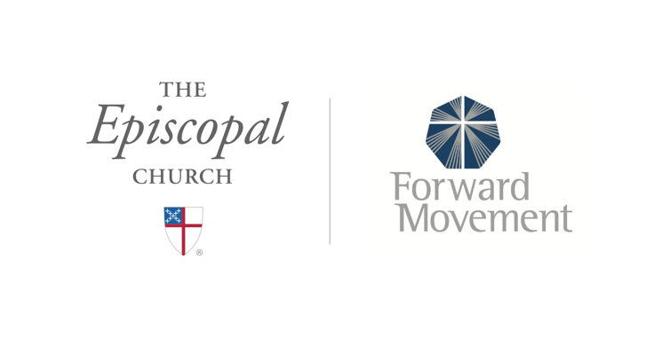
Sermons that Work and Bible Studies that Work are a joint offering of Forward Movement and The Office of Communication at The Episcopal Church.

https://www.episcopalchurch.org/bible-study/
https://www.episcopalchurch.org/sermons-that-work

