Pentecost 6 (A) – Proper 9
[RCL] Genesis 24:34-38, 42-49, 58-67; Psalm 45:11-18 or Song of Solomon 2:8-13; Romans 7:15-25a; Matthew 11:16-19, 25-30
Freedom For

This weekend marks 250 years since the signing of the Declaration of Independence in the United States.
Two hundred and fifty years. That is a remarkable milestone for a nation!
Whatever country we inhabit, whatever our political convictions, it is worth pausing to give thanks for the freedoms we enjoy, for the generations who have sacrificed to preserve them. And, in the United States. for the democratic experiment that has endured longer than many thought possible.
But anniversaries are not only occasions for celebration. They are also opportunities for reflection. They invite us to ask not only where we have been, but also who we have become.
And so, on this weekend, perhaps the question before us is a simple one: What does freedom actually mean?
For 250 years, Americans have debated that question. Most of us can (hopefully!) agree that freedom means freedom from tyranny, freedom of speech, freedom of religion, freedom of assembly, freedom to participate in the shaping of our common life. These are precious gifts, and if we are lucky enough to enjoy them, we should never take them for granted.
But the readings appointed for today suggest that there is a deeper question still. Not simply, “Are we free?” but, “What are we doing with our freedom?”
Because political freedom and spiritual freedom are not the same thing. The Apostle Paul understood that. In our reading from his letter to the Romans, Paul says something startling: “I do not do the good I want, but the evil I do not want is what I do.” I suspect most of us know exactly what he means!
We know the experience of wanting to do one thing and finding ourselves doing another. We want to be patient, but we lose our temper. We want to be generous, but we cling tightly to what we have. We want to forgive, but we carry old grievances. We want to love our neighbors, but fear and prejudice get in the way.
Paul is describing a kind of bondage that no government can solve. A nation can be politically free while its people remain captive—to greed, prejudice, hatred, violence, selfishness, addiction, or despair.
The founders of this country understood that free societies require virtuous citizens. Paul goes even deeper, though. The problem is not simply that we sometimes make bad decisions. The problem is that there are forces within us that distort us from becoming the people God created us to be.
And what is true of individuals can also become true of nations. The contradictions Paul sees in himself can become embedded in an entire society. We can proclaim liberty while tolerating (or even propagating) injustice. We can celebrate equality while excluding some of our neighbors. We can speak of human dignity while turning away from those who are suffering or most vulnerable. We can honor freedom while failing to ask whether everyone truly has the opportunity to flourish.
The Christian faith has never allowed us to imagine that freedom alone is enough. Freedom is not an end in itself. The question before us is always: freedom for what?
And it is precisely there that Jesus enters the conversation.
“Come to me, all you that are weary and are carrying heavy burdens, and I will give you rest,” he reassures his followers in our Gospel story for today.
Notice what Jesus does not say. He does not promise victory. He does not promise wealth. He does not promise national greatness. He does not promise that our side will win. He promises rest.
And perhaps that sounds almost disappointingly small—until we stop and consider how many people are weary. How many people are carrying burdens! People burdened by grief, by illness, by loneliness, by economic uncertainty, by fear about the future, by the relentless anger and division that seem to define so much of public life.
Jesus’s vision of a healthy society looks very different from the measurements we often use. We tend to measure success through wealth, power, military strength, economic growth, influence.
Jesus poses a different question: Are the weary finding rest? Are burdens being lifted? Are people being treated with gentleness?
And then Jesus names something even more surprising: “Learn from me; for I am gentle and humble in heart.”
This is the turning point. The highest value is not power as we usually define it. Not strength as domination. Jesus paints a different kind of life entirely.
Gentleness and humility are not traits we often celebrate in public life today. We admire strength. We admire confidence. We admire winning. But Jesus points us toward a better way of being human. The power of God appears not in domination but in humility, not in coercion but in love, not in crushing enemies but in carrying burdens.
If we want to know whether our lives—or our nation—are becoming more aligned with God’s kingdom, then question we should ask is much simpler: Are we becoming more like the One who speaks to us this way?
That may be one of the most challenging questions we can ask—particularly, for those in the United States, on a weekend devoted to celebrating freedom. Yet Jesus reveals that true freedom is not merely the ability to do whatever we want. True freedom is the ability to love, the ability to serve, the ability to become the people God created us to be.
And that is where our other readings meet us this morning. In our first reading from Genesis, Rebekah, who has been chosen to be Isaac’s wife, is asked a simple question: “Will you go with this man?” And she answers, “I will.” She leaves behind everything she has ever known and steps into a future she cannot yet see.
In the Song of Songs, the beloved hears another invitation: “Arise, my love, my fair one, and come away.” Winter is over. A new season is beginning. Flowers are blooming. The world is coming alive.
Both readings show moments of invitation. Neither is about coercion. Neither is about force. Both are about the freedom to say “Yes.” The freedom to respond to a call. The freedom to trust. The freedom to step into God’s future.
And perhaps that is what Christian freedom ultimately means: not merely freedom from something, but freedom for something: freedom for love, freedom for compassion, freedom for justice, freedom for mercy, freedom for building communities where every person knows they belong, freedom for participating in God’s work of healing the world.
So, on this 250th anniversary of America’s founding, perhaps the question before us is not simply whether we are free. Perhaps the deeper question is what we are doing with our freedom.
Are we using it only for ourselves? Or are we using it to build a society where burdens are lighter, where the weary find rest, where the vulnerable are protected, where strangers are welcomed, where power is exercised with humility, where love of neighbor is more than a slogan?
The Gospel does not ask us to reject our love of country. But it does ask us to measure every nation—including our own—against the character of Jesus Christ.
And Jesus, remarkably, tells us that the deepest truth about power is not greatness but gentleness: “Learn from me; for I am gentle and humble in heart.”
May God give us the wisdom to use our freedom well. And may God help us become the kind of people, and the kind of nations, that more closely reflect the gentle and humble heart of Christ.
Amen.
The Rev’d Edmund Harris serves as associate rector at St. Thomas Church in Medina, Washington. Prior to St. Thomas, Edmund served for eight years as rector of St. Peter’s Episcopal Parish in Seattle. Before moving to the west coast, he helped to found Church Beyond the Walls, a street-based worshiping community in Providence, Rhode Island, and served as assistant rector at Church of the Epiphany in East Providence, Rhode Island. Edmund is a graduate of the University of Virginia, the University of Chicago Divinity School, and Berkeley Divinity School at Yale.

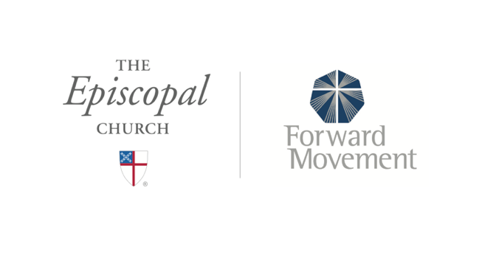
Sermons that Work and Bible Studies that Work are a joint offering of Forward Movement and The Office of Communication at The Episcopal Church.

https://www.episcopalchurch.org/bible-study/
https://www.episcopalchurch.org/sermons-that-work

