Pentecost 3 (A) – Proper 6

[RCL] Genesis 18:1-15, (21:1-7); Psalm 116:1,10-17; Romans 5:1-8; Matthew 9:35-10:8,(9-23)

On Being Blessed

This morning’s readings invite us to think about the nature of blessing: what it means to bless and to be blessed.

Now the word “blessing” is tricky—we often use it as a stand-in for good luck or material goods. We talk about being blessed with a parking spot when we need one. Or being blessed by finding exactly the thing we need at the first store we visit.

Sometimes, it gets even more complicated. “Blessing” becomes not just a stand-in for good luck, but a way we experience that we have found favor with God. Like, we speak of being blessed with a good health result or blessed by getting a pay raise.

But such a perspective is complicated. Because if those are blessings, then the opposite must be true, too. If, when our bodies are healthy, God is blessing us, then when our bodies are battling sickness, God must supposedly be punishing us.

Or if, when we have an abundance of money, God is blessing us, then when we are going through leaner times, God must be withdrawing favor from us.

You might sometimes see the label “#blessed” on social media posts when someone is casually bragging about their aesthetically beautiful life. At the bottom of a family picture, perhaps, where everyone is wearing matching outfits. (Of course, the reality of wearing scratchy, matching clothes, especially for children, doesn’t usually feel hashtagblessed.) Maybe you have some of those memories from your own Easter or Christmases past. What we see online can be a mask. It is curated – not real life. And yet, it is easy for us to compare that curation to our own realities, often seeing ourselves in the worst light while we see others in the best.

In our reading this morning from the book of Genesis, we see God fulfilling the promise God made to Abraham by giving Sarah and Abraham a child, even in their very, very old age. It seems that this child is an answer to prayer—a sign of God’s faithfulness. And, as children often are, Isaac is a blessing. He seems to be a sign that the couple has found favor with God. Except. . . does that mean that any couple who has struggled to conceive is out of favor with God?

The story is often read simply— there is a problem, that is: childlessness—and God’s answer, God’s presence, God’s favor is manifested in the “solution” to this problem: Sarah conceives and bears a son.

Many of us know someone who has tried and been unable to add a child to their own family. Maybe it was you, or a close friend, or a family member. Chances are, in this congregation, someone has considered IVF; someone has prayed fervently that God would help them conceive. Someone might even be in the middle of that struggle. And, so, this interpretation is important to understand as an interpretation, not as the story’s one meaning. While it is a possible reading to see that God’s blessing and favor as equated with Abraham and Sarah being given a child, that is not the only reading. God’s presence is not always manifested by a simple answer to our complex yearnings. Receiving God’s blessing—being blessed—is more robust and meaningful than just getting our own way. God is not a wish-granting factory.

The complicated nature of God—and God’s way of giving—is revealed in our gospel. After telling the apostles that there will be a lot of work to do, Jesus tells them, “You received without payment, give without payment.”

Think how contrary that runs to the way of the world! The world runs on earning and deserving. America, in its idea of itself, is a meritocracy—there’s a belief that you get what you deserve based on your own merit. If you work hard enough, you should be able to have a good life. You earn your way forward.

But if a good life is earned, by American logic, then is a bad one, as well? If you have a hard life—if you’re struggling to pay your bills, or you can’t get along with your kids, or you got fired from your job—do you deserve it?

Of course, we know that meritocracy doesn’t always—or even often—work. Life isn’t fair. Bad things happen to good people, and sometimes really good luck happens to people who we feel like don’t deserve it at all. In fact, deserving seems to have very little to do with any of it. And neither does merit. Neither does hard work.

What Jesus teaches the disciples doesn’t so much grapple with deserving and undeserving—who earns what—rather, it introduces an entirely different economic system. Jesus is talking about gifts. He teaches about receiving God’s love and God’s presence as a gift. Not because we earned it, not because we deserve it, not because we are good, but because God is good.

This brings us back to the idea of blessing. Blessing isn’t about having our prayers answered the way we hope for. It’s not about receiving something wonderful. Blessing is about God’s goodness—God’s faithfulness—in our lives.

God’s blessing is God’s presence with us. And that presence is here when we get our way and when all the chips are down. God blesses us right where we are, on great days and on garbage days, because God is with us always.

So, maybe the blessing that Abraham and Sarah receive isn’t in Isaac being made manifest to them; it is in God walking with them through years of yearning.

We are blessed by that same presence, a gift we received before we even knew how to ask for it. God is with us when we struggle and when we succeed. God is with us as we pray in frustration and as we lift our voices in praise. God’s very presence with us offers us a blessing—not by changing our circumstances, but by accompanying us in them. We are not alone, no matter what lies ahead of us.

So, this morning, no matter where you are, may you be blessed.

May you come into the realization that God is here with you, right now, no matter what.
May you receive the gift of God’s immense grace and unchanging love.
May the eyes of your heart be opened to see that God is blessing, and blessing, and blessing us.
Amen.

The Rev’d Jazzy Bostock is a kanaka mail woman and serves two communities in Wai'anae on the west side of Oahu, St. John the Baptist Episcopal Church and Maluhia Lutheran Church. She and her wife have two boys, Theo, 5, and Sam, 1, a garden, some chickens, bees, a cat and a dog. She loves to garden, cook, laugh, and be barefoot.
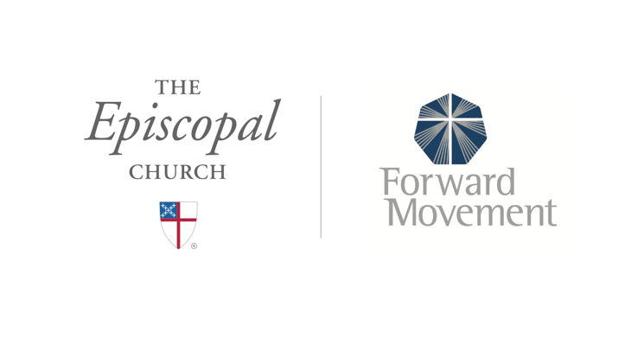
Sermons that Work and Bible Studies that Work are a joint offering of Forward Movement and The Office of Communication at The Episcopal Church.

https://www.episcopalchurch.org/bible-study/
https://www.episcopalchurch.org/sermons-that-work

