Pentecost 9 (A) – Proper 12
[RCL]: Genesis 29:15-28; Psalm 105:1-11, 45b, Romans 8:26-39, Matthew 13:31-33,44-52

Love the Questions

Today’s reading from the Epistle to the Romans includes some of the most familiar and comforting words from Paul the Apostle, messenger, teacher and preacher: “For I am convinced that neither death, nor life, nor angels, nor rulers, nor things present, nor things to come, nor powers, nor height, nor depth, nor anything else in all creation, will be able to separate us from the love of God in Christ Jesus our Lord.”
Paul had spread the message of Christ throughout Asia Minor and would pass through Rome on his way to evangelize in Spain. Paul’s letter was written to the Christians in Rome in advance of his visit to them. The Christian community in Rome was composed of both Jews and Gentiles, and there was likely some division along those lines. While this letter is directed to the concerns and needs of his audience, Paul also focuses his teaching on truths about the church as a whole: the gospel of salvation is for everyone. His primary theme in these pages is justification, or how to be in right relationship with God.
Today’s readings are rich with some of the most comforting words in the Scriptures. For instance, we read that we do not know how to pray as we ought. (And most of us agree with that statement—with a sigh of regret or longing, perhaps.) But Paul goes on to reassure us: The Spirit intercedes with sighs too deep for words. God searches our hearts. And nothing can separate us from the love of God in Christ Jesus. This all is poetry, music for the soul.
After assuring his readers that God knows what is in our hearts, even when we don’t have the words to pray, Paul asks a series of rhetorical questions: If God is for us, who is against us? Who will separate us from the love of Christ? He follows with a list of assurances: Neither death, nor life, nor angels, nor rulers, nor things present, nor things to come, nor powers, nor height, nor depth, nor anything else in all creation can come between us and God's complete, perfect, all-knowing love.
It might be useful, and rich, and enlightening, to list our own fears of what might separate us from the love of God. What are your own challenges to your relationship with God? Perhaps addiction, or depression, anger (you can be specific here!). Greed, worship of the idols of money and material success? Over-confidence, pride, hubris?
Paul asks us to live by faith. God cannot love you less, nor more. Live like God loves you.
Today’s readings are also rich with challenges. In the Gospel According to Matthew, Jesus challenges us to imagine the Kingdom of Heaven. He creates a series of similes: the kingdom is heaven is like a mustard seed, like yeast, like hidden treasure, like a pearl of great value, like a net full of fish.
Again, it might be a meaningful activity to make our own comparisons. What do you understand the kingdom of heaven to be like?
What if the kingdom of heaven is a place of surprises? Where we learn to stretch beyond our comfort zone? Where we discover that uncomfortable is good?
Going back to our reading from Genesis, we read that Jacob is surprised to find Leah in his bed, rather than Rachel. From that surprise, six sons were born. Jacob had to stretch beyond his comfort zone, into God’s plan, and those sons are important in biblical history as the leaders of six of the twelve tribes of Israel. Or we could consider Jesus’s mother, Mary, who was likely quite surprised to hear from the angel that she was to bear a child, though an unwed woman. In the end, she bore the savior of the world. Unexpected, uncomfortable surprises that led to the kingdom of heaven.
Live like you inhabit the kingdom of heaven, because the kingdom of heaven is all around us. Today’s reading invites us to see the mustard seed as a metaphor for our own actions. One tiny, good deed, act of mercy, moment of faith, will grow huge in many dimensions. While we are thinking creatively with Scripture, we might also try listing mustard seed moments. When did a small seed you planted grow into a shelter for countless living things?
The important message between these passages—one that Jesus teaches us, that Paul reminds us—is that God is always within and around us. The Holy Spirit prays within us, even when we forget to pray. The kingdom of heaven is within and around us, even when we are in doubt or fear. This is the promise of our faith. So let us not lose hope—which is the future tense of faith. May we meet our fears and uncomfortable moments, embrace the surprises. May we learn to trust ourselves and others, as we trust our God.
Let us close today with some words about embracing the surprise of life from the German poet Rainer Maria Rilke, who spent a lifetime searching for a meaningful basis for living—a project one might characterize as a search for the kingdom of heaven. He published a poetry collection exploring his search, entitled The Book of Hours. While Rilke struggled with finding language to define and describe God, how poetic, how beautiful, how faithful is the suggestion of this collection’s subtitle: Love Letters to God.
Rilke famously wrote in his Letters to a Young Poet: “learn to love the questions themselves.” Maybe the poet is right. Maybe the kingdom of heaven is a place where we learn to love the questions, a place where we surrender to the life the Holy Spirit is praying into being within us.
Let us listen to the words of one of Rilke’s love poems to God (Book of Hours, I 59):

God speaks to each of us as he makes us,
then walks with us silently out of the night.
These are the words we dimly hear:
You, sent out beyond your recall,
go to the limits of your longing.
Embody me.
Flare up like a flame
and make big shadows I can move in.
Let everything happen to you: beauty and terror.
Just keep going. No feeling is final.
Don’t let yourself lose me.
Nearby is the country they call life.
You will know it by its seriousness.
Give me your hand.
Amen.

Susan Butterworth is a church musician and ministerial associate at St. Michael's Church, Marblehead, MA. She is a writer, singer, and equestrian. She has taught English at Salem State University, and is retired from the Episcopal chaplaincy at MIT (Massachusetts Institute of Technology), where she led Taizé prayer for many years.
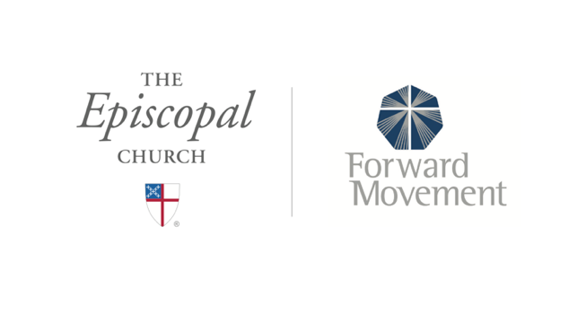
Sermons that Work and Bible Studies that Work are a joint offering of Forward Movement and The Office of Communication at The Episcopal Church.

https://www.episcopalchurch.org/bible-study/
https://www.episcopalchurch.org/sermons-that-work

