Christmas I

[RCL] Isaiah 61:10-62:3; Psalm 147; Galatians 3:23-25;4:4-7; John 1:1-18

What Happens After the Miracle?

Let’s start with the obvious: for many people, it’s not really clear why we’re here in church today. We’ve just come off a great festival of Christmas services, with music and candles and all the spectacle you could ever want. So we have to ask the obvious question: why are we here this morning? Most sensible people are just turning over in bed, having drifted lazily awake to realize they don’t have to get up, they’ve already done church this week. There are tasty leftovers in the fridge, the morning is just getting started outside the window, and isn’t it wonderful to punch the pillow into shape and settle in for some more sleep?

But not us! We slapped at the alarm clock and got up anyway, grabbed a bite of cold turkey on the way out the door, and made our way to the doors of our church. What are we doing here the week after all the big celebrations?

Mary and Joseph probably had somewhat of a holiness hangover themselves after the big event. They woke up that first morning in the cold stable, and the shepherds and angels were gone. Baby Jesus was fussy, and they were suddenly nervous new parents far from home with no relatives or friends to help them learn to manage a newborn. Joseph had to learn to change swaddling clothes, and Mary’s aching body wanted nothing more than to rest in a real bed instead of a handful of scratchy straw over a hard stable floor. Joseph had to find food to keep his family going, and Mary had to face the real danger of childbed fever or any other number of threats to her and her child in a time and place without sanitation or adequate healthcare.

And what was the week after like for the shepherds? They had had a truly extraordinary experience while out in the fields—with the heavenly host appearing and singing to them—and then had left the sheep to go down into Bethlehem and barge in on a woman just out of labor. They adored the Christ Child and then left, and they probably asked each other the next morning, while they rounded up their scattered sheep, if it really happened or was all a strangely vivid dream. The gospel says that they told everyone they met about the miracle, but there was not a rush of townspeople to the stable. Luke says that everyone was “amazed,” but “amazed” may mean privately telling one another that the thin air up on the hillsides had gotten to the shepherds.

It’s the week after, and all of us—Mary, Joseph, the shepherds, and we little band of pilgrims gathered here this morning—kind of have that feeling of being washed up on shore after a shipwreck.

What happens afterward is an endlessly fascinating mystery. The Bible never tells us what happens on the days after; there wouldn’t be time or space. We hear of a big important event and then it’s on to the next big important event, and we have to try to imagine ourselves what happened the next week.

What happened after the angel stopped Abraham from killing Isaac? When Sarah asked how their day was, did they tell her what happened?

What happened after everyone got off the ark, and Noah thanked God for the rainbow? Did they all watch the sky for rain and think about how they were never getting back on a boat ever again no matter what kind of voices Noah heard?

What happened after Lazarus was raised from the dead? Did he go back to work and terrify all his coworkers?

What happened after Pentecost? Did the disciples check to see if the tongues of flame had singed their already-receding hairlines?

It’s a great question, because they all had to face the days after, everyone from Adam and Eve to Mary and Joseph. They all had to contend with the knowledge that, despite the wonder of God breaking into their lives, in some sense the normal ways of doing things still carried on. They had to pick up the pieces of their lives and keep going, even though maybe no one else understood that everything was different, and nothing could ever be the same.

So let’s ask ourselves the same question. What happens on the day after, the week after, the month after? One thing about people in the Bible is that they always knew that their previous realities had been shattered. What about us? When we chose not to turn over and go back to sleep this morning, what made us get up and come to church?

The answer may lie in one short verse about Mary soon after Jesus’ birth. Luke 2:19 reads, “But Mary treasured all these words and pondered them in her heart.” There’s something every person in this room has in common with Mary: We are seekers. We’re not saying the folks at home in bed are not seekers, but something inside each of us drove us to get here to this place this morning, and it is the same something that allowed Mary to welcome the words of the angel with curiosity and awe.

The hunger to know what happens next in this journey with God can take different forms for each of us. Some of us came here overflowing with thanksgiving for a beautiful Christmas and a year of blessings. Others of us came here because it feels like there’s something missing in our hearts. Maybe our souls are heavy with loss or fear, and we’re asking God, what happens next? The shepherds and the angels have left the stable—is there room there for us?

And the answer is “Yes.” The greatest thing about the days after is that they are unwritten. They are a blank page waiting for our choices and actions to write the story. Take a moment and ponder the unwritten story of your days after. There are many possible many plotlines, many questions unanswered in your heart that are part of what drew you to seek the presence of God in church here today. It’s such a vital question in this unsettled time. We’re all asking in so many ways: what happens next?

The question can seem vast and frightening, as indeed it must have that first week after for Mary and Joseph. But for Mary and Joseph—and for us—the answer is right in front of us: in this small child whose presence, even as a baby, brings us to our knees in the beauty of his holiness.

We have known something that Abraham and Noah and David only had glimpses of from a far distance. Each time we ask what happens after the big moment, we know that, whatever happens, nothing can take us outside the love of Jesus Christ. Whether the next moment brings unimaginable joy, heartbreaking tragedy—or what is more likely, a long string of ordinary struggles and humdrum events—there is something new and different from now on. On these days after, the world has changed, because God has come to dwell with us as a person, as our own Jesus Christ, who loved us through death and beyond.

So praise God for getting us out of bed and to church on this cold morning! Our curiosity about what happens next is one of the most vital forces keeping our spirits alive and kicking no matter what life throws at us. There will always be someone to tell the story of the big events, the days full of fireworks and bells and cheers. Who will tell the story of what happens after?

We will. We as a community will keep asking the question, because we know that the best part of the story is already written but always waiting to be discovered: that the Word became flesh, and dwelt among us.

The Rev. Canon Whitney Rice (she/her/hers) is an Episcopal priest who serves as the Canon for Evangelism & Discipleship Development for the Episcopal Diocese of Missouri. She is a graduate of Yale Divinity School, where she won the Yale University Charles S. Mersick Prize for Public Address and Preaching and the Yale University E. William Muehl Award for Excellence in Preaching. She has taught undergraduate courses at the University of Indianapolis and has contributed to Lectionary Homiletics, the Young Clergy Women’s Project journal Fidelia’s Sisters, and other publications. She has served as a researcher and community ministry grant consultant for the Indianapolis Center for Congregations and is currently a member of The Episcopal Church’s Evangelism Council of Advice. A communicator of the gospel at heart, she writes and teaches on a wide variety of topics, including rethinking evangelism, stewardship, leadership, women’s theology of the body, mysticism, and spiritual development. When she’s not thinking about theology, particularly the intersection of evangelism and justice work (which is all the time, seriously), you’ll find her swing dancing. Find more of her work at her website Roof Crashers & Hem Grabbers (www.roofcrashersandhemgrabbers.com).

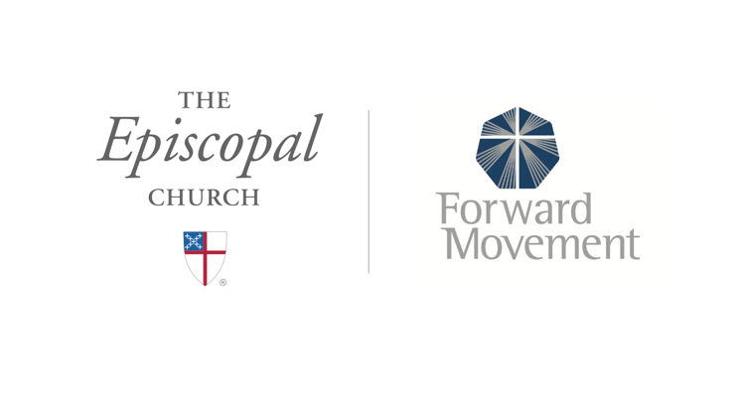
Sermons that Work and Bible Studies that Work are a joint offering of Forward Movement and The Office of Communication at The Episcopal Church.

https://www.episcopalchurch.org/bible-study/
https://www.episcopalchurch.org/sermons-that-work

