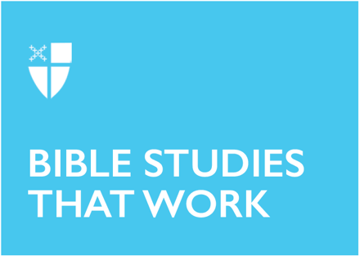

Christmas 1 (A)
December 28, 2025
RCL: Isaiah 61:10-62:3, Psalm: 147, Galatians 3:23-25; 4:4-7, John 1:1-18
Opening Prayer |
Almighty God, you have poured upon us the new light of your incarnate Word: Grant that this light, enkindled in our hearts, may shine forth in our lives; through Jesus Christ our Lord, who lives and reigns with you, in the unity of the Holy Spirit, one God, now and for ever. Amen.
Context |
The opening passage of the Gospel of John falls on the first Sunday of Christmas, when priests still wear white vestments and all the candles remain lit. The joy and promise of Christmas cannot be contained in just one or two days; the Church needs a full twelve days to appreciate all the delight that God Incarnate has brought! Yet on this day, the first Sunday following Christmas Day, the lectionary shifts from the obvious joy of a baby, angels, and gifts, to a totally different kind of infancy narrative. This Christmas narrative has no manger that can contain it; it would make a truly terrible Christmas Pageant. Instead, the author of John’s Gospel uses the Greek word logos to say something cosmic about God’s incarnation.
Logos is not actually a straightforward term in Greek. It is translated as “Word” in John’s Gospel in English. But Greek playwrights and philosophers use the word logos differently. Sophocles uses logos as “promise;” Aeschelus as “command.” Herodotus and Thucydides will both make logos mean “story,” ignoring the other options in Greek for story (like mythos or poesis). Instead, they will use logos as an undoubtedly true story, but told by another. Logos has also been used as “reason.” The Word, as it turns out, is a little nuanced.
This Word, written in Greek, with a long genealogy coming from both Jewish and Hellenic thinkers, was chosen by the author of John’s Gospel to capture the overwhelming truth, grace, and light that was clothed in human flesh and blood, who came forth to save creation. What kind of Word was this God, to be both command and promise, reason and wit and story?
Theological Reflection |
During the first Sunday of Christmas, the Church speaks the Word of light that still shines in the darkness, which the darkness does not overcome. Some people are perhaps carrying their own words of darkness with them. (So many do.) But with the coming of Jesus—a Word for all—a new story can be carried: no matter how dismal the dark, the light stays. The light shines.
The true light, which enlightens everyone, illuminating all hearts and souls and minds, scatters the darkness in all times and all places. Our God came to us not just on one night of the year, not only wrapped in burlap or with a single choir of angels and shepherds, but God comes to everyone, every day, in every moment. This is what it means that God came as the Incarnate Logos: Logos is a noun, yes, but a noun that implies taking action. Stories require telling; promises demand keeping, and reason rests on relationships. And light? Light requires a source to shine. Jesus tells us over and over that he’s not the only one meant to embody this Christmas Word, and John’s Gospel offers up many words for how to do it: being, attending, relating, creating, existing, living, testifying, illuminating, shining, enlightening; accepting, receiving, believing, seeing, knowing, becoming children of God through the Son. But the most important of these works is embodying: embodying forgiveness, embodying healing, embodying peace and grace and love. God refused to cede the world to darkness and chaos, and so God was born in a human body to share God’s light with this shadowed, broken creation. Through the work of Jesus, Christmas comes to everyone, again and again: good news to the poor, humility and hope to the wealthy, healing and freedom to those marked by shame. Given the use of the imperfect tense of the Greek verb en in John 1:1 (“In the Beginning was the Word”), we know that this Word’s action is habitual and ongoing. This Word always has been and still is the work of God in the world. This is the Church’s work now, too.
No one has ever seen God; it is Jesus who made God known. And it is the Church—its prayers and work, its commitment to light, hope, and mercy, and faith in the sacraments—that makes Jesus known to others. Every time the Church offers gifts and songs to lonely neighbors or carries meals to families impacted by poverty; every time the Church pours out healing oil onto cracked and trembling hands or puts herself between disaster and another’s dignity—the Church embodies God, too. This is Christmas work, and it is work for all year.
The Word became flesh and dwelt among humanity—in Jesus, among enemies, with neighbors—and God’s Glory is seen: in the lost who are found, in the broken who are healed, in the hungry who are fed, in the imprisoned who are released, in the nations rebuilt, in the people at peace.
Let this music resound in all hearts: that God did not leave the world to the darkness, but made humanity into stars of light and choirs of the Word, not only on Christmas day, but every day.

Reflection Questions |
- Where in your life do you see the light of God?
- Choose one verb from the Gospel passage. How might that verb help you embody the work of Christmas more fully?
- Who in your community might need a word of light from you? How might you deliver it to them?
- How can you practice intentional storytelling? How might you embody the story of hope, love, and mercy in your particular contexts?
Faith in Practice |
This week, light a candle, seek out the stars, or watch your Christmas tree lights each night. As you meditate on their glow, write down any words that come to mind. Reflect on them: are they words of longing? Reconciliation? Loneliness? Joy? Fear? Let those words be brought into the light and act as a reminder of the Word who became flesh to scatter the dark. Tend to these words and wonder: how might they lead you to embody the work of Christmas to those who need it?

Ms. Chesirae Valentine-Karlin is a seminarian at the General Theological Seminary, the Director of Children and Youth at All Angels’ Church on the Upper West Side, and a postulant to the priesthood from the Diocese of Arizona. When not writing papers or teaching acolytes, she’s probably playing in Central Park with her husband James, son Beckett, and cat Ruah.

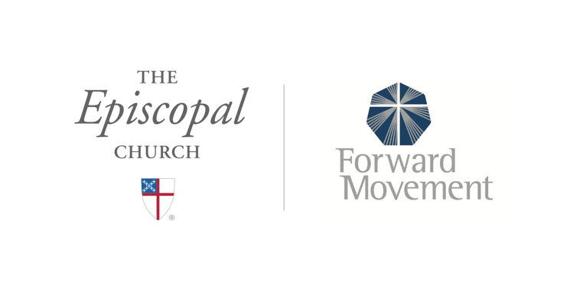
Sermons that Work and Bible Studies that Work are a joint offering of Forward Movement and The Office of Communication at The Episcopal Church.

https://www.episcopalchurch.org/bible-study/
https://www.episcopalchurch.org/sermons-that-work

