Advent 3 (A)

[RCL] Isaiah 35:1-10; Psalm 146:5-10; James 5:7-10; Matthew 11:2-11

Answer

We want answers, most days. We crave them; we seek them; sometimes we demand them. We peer at stars and read between lines and survey the vast, muddied landscape of our experiences, hoping to catch sight of something clear and telling.

Often they are quite matter-of-fact, the questions we ask and the answers we seek: What should I make for dinner? Where should I go next weekend? How long ‘til Christmas?

And yet at other times, the questions are more subtle and lingering: What should I make of my life? Where should I go to feel like I am not alone? How long ‘til Christ makes all things new?

But whether our questions are practical or existential, decisive answers are usually what we’re after. And because we are formed and guided by words, we often imagine an answer as a thing that coheres nicely into a single phrase or insight. Surely, we think, whatever it is that we want to know is waiting out there just beyond the tip of our own tongues.

Unfortunately, though—perhaps more often than we’d care to admit—answers are not so easily translated into simple turns of phrase. And the more important the question, the more likely that this is so. Despite our human fascination with fortunes told and secrets disclosed, the truth is that answers to our most profound questions are more often discerned slowly, in broad shapes and patterns of meaning, than they are discovered in revelatory, obvious flashes.

This is important for those of us who follow Jesus on the Christian path, and it is especially important in this Advent season, when we engage the sense of heightened anticipation that God will, somehow, come and make an answer to all of our enduring sorrows and longings. What is the Word we await? What sort of answer are we expecting to receive from on high? A crisp, clear phrase with which to flatten our enemies; to unlock the mysteries of the ages; to solve the conundrums of ourselves?

What if that is not what’s coming?

In today’s Gospel, John the Baptist has a question, too, and it’s quite clear that he wants a “yes” or “no” sort of answer. Are you the one who is to come, or are we to wait for another?

So much—everything, really—depends on the answer, and we can’t blame John for wanting to know plainly. He has given his whole life over to this question. He has been made wild and holy by the yearning of this question. He has become stricken by the weight of this question. And ultimately, he will die for the implications of this question.

Because to ask whether Jesus is “the one who is to come” is, in itself, to assert that nothing and no one else in this world can be. No emperor or king, no treasure, no philosopher or fortune-teller can contend with “the one who is to come,” because this One will be the answer to every question and the remedy to every wrong. And so, of course, as his own days dwindle down in captivity, John desperately wishes to know if his waiting has been in vain.

He, too, is asking: What have I made of my life? Am I alone? How long ‘til God makes all things new?

And yet, as is so often the case, Jesus does not answer John’s question directly.

Just as when he teaches in parables, Jesus replies to John in this moment with images and with an invitation to look closely at them. Go and tell John what you hear and see: the blind receive their sight, the lame walk, the lepers are cleansed, the deaf hear, the dead are raised, and the poor have good news brought to them.

In other words: John, the answer is all around you. It is not found in simplistic assertions of identity or authority. It is in the shapes and patterns of healing and life and justice that come forth wherever love reigns.

Anyone can claim to be a messiah or a king—and goodness knows many have done so. But only God can bring forth the fruits of the Kingdom within us and among us. Only God can transform our wildernesses into a sanctuary. Only God can show us how to be the answer rather than just wait for one.

This is the essential paradox of the Messiah we are shown in Jesus: he is the expected one who will not conform to our expectations. He is the one who has come, and yet he points away from himself the moment he arrives. He does not respond directly in part because he refuses to succumb to the idolatry of easy answers. And it is perhaps in this refusal—in Jesus’ rejection of the deceptive simplicities of our lesser gods—that we begin to know that he is the Son of God. For only Truth would be content to let the results speak for themselves.

So what does this mean for us—we who, like John, are still captive to the world’s many ambiguities and are still hungering for a clear and piercing response to our questions?
It means, quite simply, that we must reorient our search for answers. The things we are seeking to understand as followers of Jesus are not insights locked away somewhere, reserved for the especially wise or powerful or pious. The answers, instead, will always be found in the living enactment of the good news: the practice of love and righteousness in our churches and communities and homes. The real answers are to be found in doing the same things that Jesus did: listening, healing, reconciling, liberating, giving thanks, and letting go. And if we do these things, then we will look back one day and say, Oh, yes, I see: there it was. There was my answer. There was all of the answers, to every question.

It means, too, that we should be wary of any institution or figure—political, religious, or otherwise—who claims that they alone have the answer or, even worse, that they are the answer. In the face of such assertions, we must resist and remember that even Christ himself was loathe to claim his identity as the Messiah. He was most concerned with helping others find their own inherent dignity, not with them worshipping his. Let that be a benchmark for the ones whom we entrust with authority.

And finally, hopefully, it means that perhaps we can rest a bit, in the midst of all our Advent anticipation. Instead of waiting with bated breath like John, with our whole lives dependent upon a single word of response from God, perhaps we can look around at how the answers to our deepest questions are already springing up around us. The answers are already being given. This is the gift and the power of a sacramental life: You will catch a glimpse of God in the gleam of a candle or in the phrase of a protest song; in a bag of groceries left on a doorstep or a hand reached out to you in forgiveness. It may come to you in the liturgy on a Sunday, or in the broader liturgy of your life.

The point is this: God’s answers are here, in the words you already know how to speak. They have come (Oh yes, John, they have already come). But they have come softly, like falling snow, like promises kept, like all those small mercies we overlook while searching the skies for grander resolutions. They have come to us, John—these answers that contain the Answer—in a way that must be lived to be believed.

The question that Jesus asks all of us is this: Will you live it? Will you dare the joy of living it?

And maybe, just maybe, in this Advent, God is waiting for our answer, too.

The Reverend Phil Hooper serves as rector of St. Anne Episcopal Church, West Chester, in the Diocese of Southern Ohio. He is a regular contributor to several Episcopal projects including Sermons that Work and the Prophetic Voices preaching podcast. You can find his sermons and other writings at byanotherroad.com.

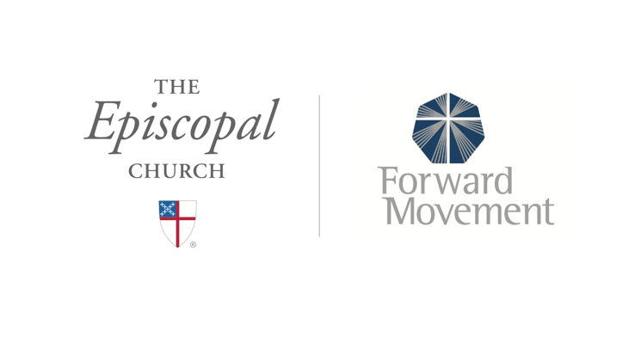
Sermons that Work and Bible Studies that Work are a joint offering of Forward Movement and The Office of Communication at The Episcopal Church.

https://www.episcopalchurch.org/bible-study/
https://www.episcopalchurch.org/sermons-that-work

